**The Taj Mahal**

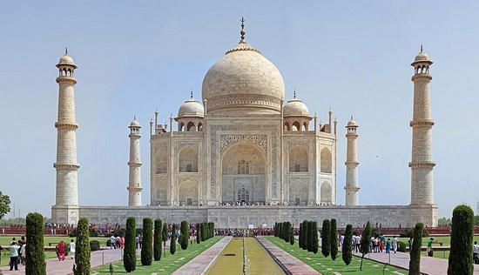

**Taj Mahal**“crown of palaces”, world heritage site is a white marble mausoleum located in Agra, Uttar Pradesh,  India, seen from the banks of Yamuna river, with Mihman Khana or assembly hall (left) and Taj Mahal mosque (right), the two almost identical buildings on either side. It was built by Mughal emperor Shah Jahan in memory of his third wife, Mumtaz Mahal. The Taj Mahal is widely recognized as “the jewel of Muslim art in India and one of the universally admired masterpieces of the world’s heritage.It coveres area about 221 hectare (552 Acres) which include 38 hectare taj mahal and 183 hectare taj protected forest are. This world’s most Famous Cultural Monuments is also one of the wonders of the world